System Requirements Specifications (SRS)

The Development for LogSpace logistics platform with Odoo v. 19

For

LogSpace

Version 1.2
15/March/2025

Prepared By Appness LLC Muscat, Oman

Table of Contents

1. Introduction 3
1.1 Purpose 4
1.2 Scope 4
2. Definitions, Acronyms, and Abbreviations 4
3. System Description 4
4. Requirement Specifications 5
4.1 General Features 6
4.1.1 Operating Environment 7
4.1.2 Design and Implementation Constraints 7
4.1.3 General Odoo Features and Configurable features 7
4.2 Functional Requirements 7
4.2.1 Guest Booking 8
4.2.2 User registration and authentication 8
4.2.3 Pickup and Drop-off Scheduling 8
4.2.4 Vehicle Search and Selection 8
4.2.5 Add-On Services Management 8
4.2.6 Provider Registration and Approval 8
4.2.7 Vehicle Management 8
4.2.8 Pricing and VAT Handling 8
4.2.9 Order Lifecycle Management 8
4.2.10 Verification code 8
4.2.11 Payment processing for future orders 9
4.2.12 Refund management 9
4.2.13 Penalty Enforcement 9
4.2.14 Helpdesk and ticketing 9
4.2.15 Notifications and Alerts 9
4.2.16 Vendor Earnings and Reporting 9
4.2.17 Ratings and Reviews 9
4.3 User Roles and Access Control 10
4.3.1 Administrator 10
4.3.2 Service Provider 10
4.3.3 Customer (Registered User) 10
4.3.4 Guest user 10
4.4 High-Level Workflow 11
4.4.1 Customer booking 11
4.4.2 Order Tracking & Fulfillment 16
4.4.3 Post-Delivery Actions 17
4.4.4 Provider (Vendor) Workflow 19
4.4.5 Management workflow 28
4.4.6 System workflow 29
5. Critical Acceptance Criteria and Success Factors 30
6. Appendix A – Additional clarification and workflows 31
7. Appendix B – Important notes 32
7.1 Users 33
7.2 Change request (CR) 33
7.3 Server and Domain 33
7.4 Data 33
7.5 Diagram and workflows 33

Introduction

Purpose
This document defines the requirements for implementing and developing (LogSpace) on Odoo 19 Enterprise as a logistics marketplace platform.
The system will provide a multilingual website, customer booking portal, service provider access, and integrated ERP backend to manage orders, vehicles, providers, payments, tracking, refunds, and reporting using standard Odoo features with necessary controlled customizations.

Scope
The scope includes configuration and customization of Odoo 19 Enterprise modules (Website, Sales, Accounting, Helpdesk, Documents, Approvals, Payment Providers, and customized solution for logistic platform) to support:
- Online booking with scheduling, add-ons, and vehicle selection
- Provider registration, approval, and vehicles management
- Order lifecycle tracking with verification codes
- Payment processing, VAT handling, refunds, and penalties
- Vendor earnings and operational dashboards
- Ticketing, notifications, chat, and reporting
- Training, multi-language, and technical support

Definitions, Acronyms, and Abbreviations
- ERP: Enterprise Resource Planning
- SRS: Software Requirements Specification
- UAT: User Acceptance Testing
- CR: Change Request
- VAT: Value Added Tax
- SO: Sales Order
- RFQ: Request for Quotation
- SLA: Service Level Agreement
- API: Application Programming Interface
- Sale Order: Odoo sale order
- Purchase Order Odoo purchase order

System Description
The system will be implemented using Odoo 19 Enterprise as a centralized logistics operations platform for LogSpace. It will unify the public website, customer booking portal, and back-office ERP into a single integrated system to manage bookings, vehicle selection, scheduling, add-ons, provider onboarding, vehicle management, order tracking with verification codes, payments, VAT, refunds, and helpdesk support.
The solution will utilize standard Odoo modules such as Website, Sales, Accounting, Fleet, Documents, Approvals, Helpdesk, Sales, Purchase, and Payment Providers, with necessary customizations to support logistics-specific workflows and complete end-to-end service and vendor revenue management.

Figure 1 LogSpace main functionalities

Requirement Specifications
The functional requirements of the system cover Website, Booking Management, Sales, Accounting, vehicles Management, Provider Management, Helpdesk, Documents, Approvals, Payment Processing, and Reporting.
This document defines the functional requirements of the above modules and related custom logistics workflows in the following sections.

Figure 2 LogSpace Requirements

General Features

Operating Environment
The system will be implemented on Odoo 19 Enterprise as a web-based application accessible through modern web browsers (Chrome, Firefox), Odoo PWA Desktop App, and Odoo Mobile applications.
The platform will be hosted on cloud infrastructure and requires a stable internet connection for full operational access by customers, service providers, and administrators.

Design and Implementation Constraints
Implementation must be based on Odoo 19 Enterprise and its standard supported modules.
• Customization must be limited to logistics marketplace workflows not covered by standard configuration.
• The system must be scalable to support increasing users, providers, vehicles, transactions, and data volume.
• To use existing Odoo supported payment getaway or to provide the payment getaway before starting the wireframe stage.

General Odoo Features and Configurable features
The system must allow configuration of:
• Logo
• Company name
• Address
• Tagline
• Contact details
• Bank information
• Headers and footers
• VAT and Tax Identification details
• Selectable fonts and color themes (within Odoo standard options)
- Multi-Language
Support for English and Arabic (standard Odoo), with other Odoo available languages enabled through translation configuration.
- Master Data Import
The system must support importing master data including providers, vehicles, customers, chart of accounts, analytic accounts, users, and related records.
Supported formats: .csv and .xlsx.
- Data Export
The system must support exporting records in .csv and .xlsx formats.
- Activity Types
Support configurable activity types such as:
• To-do
• Send Email
• Upload Document
• Phone Call
• Schedule Meeting

Functional Requirements

Guest Booking
The system shall allow booking without mandatory registration. Order details are sent by email, and history becomes visible if the user later activates the account using the same email.

User registration and authentication
The system shall allow customers and providers to register using email with password and email.

Pickup and Drop-off Scheduling
The system shall allow selection of pickup and drop-off dates with configurable time slots defined by management. Future bookings must be supported.

Vehicle Search and Selection
The system shall display available vehicles based on pickup location, destination, service type, and date. Results must reflect providers' availability and pricing.

Add-On Services Management
The system shall support configurable add-ons such as storage (size-based per day), refrigeration requirements, custom clearance, packaging, handling, installation, and dismantling services.

Provider Registration and Approval
The system shall provide a registration form for service providers including CR, revenue, insurance, documents, and logo upload. Admin approval is mandatory before activation.

Vehicle Management
Providers shall create and manage vehicles including base hub, pricing matrix by zones, size category, insurance status, technical data, and availability.

Pricing and VAT Handling
The system shall calculate pricing based on vehicle, zones, add-ons, VAT must be applied based on provider tax configuration and location rules.

Order Lifecycle Management
The system shall manage defined states: received, confirmed, pickup started, arrived, pickup completed, drop-off completed, grace period, completed. State transitions must be controlled.

Verification code
The system shall generate pickup and drop-off verification codes. Codes must be shared with the customer and validated by the provider before completing the workflow.

Payment processing for future orders
The system shall require fixed booking fees amount (not refundable) for confirmation of future orders, and the rest of the amount to paid before order start. If payment fails for future payment or normal order, the order remains saved, and a continuation link is sent by email.

Refund management
The system shall automatically apply refund rules: 100% at booking stage, 50% at started stage, 0% at pickup stage, and the refund will be processed by the management team.

Penalty Enforcement
The system shall apply provider penalties in case of no-show or delay based on predefined business rules.

Helpdesk and ticketing
The system shall allow ticket creation linked to confirmed orders. Tickets remain accessible to customers and administrators.

Notifications and Alerts
The system shall send automated notifications for order status changes, payment confirmation, verification codes, and system alerts.

Vendor Earnings and Reporting
The system shall calculate completed order revenue per provider and display earnings summary and withdrawal history.

Ratings and Reviews
The system shall allow customers to submit star ratings (1–5) and comments after order completion.

User Roles and Access Control

Figure 5 LogSpace users and roles

Administrator
Full system access across Odoo Website, Sales, Purchase, Accounting, Vehicles, Providers, Payments, Refunds, Penalties, Documents, and Reports.
Responsible for provider approval, configuration, VAT setup, pricing rules, workflow control, and user management.

Service Provider
Access limited to their own company profile, uploaded documents, vehicles, pricing matrix, availability status, assigned orders, order status updates, and earnings summary.
No access to other providers’ data. Deletion of records is not permitted, availability toggle only.

Customer (Registered User)
Access to profile management, saved addresses, booking creation, order history, payment, ticket submission, chat, tracking screen, and ratings.
Cannot access provider internal data or other customers’ records.

Guest user
Access limited to booking creation and payment using email without full registration.
No profile access or historical data visibility unless the account is later activated using the same email.

High-Level Workflow

Customer booking
- Pickup & Drop-off Screen (Main screen on the website)
  - Select pickup date & time frame
  - Select drop-off date & time frame
  - Choose service type
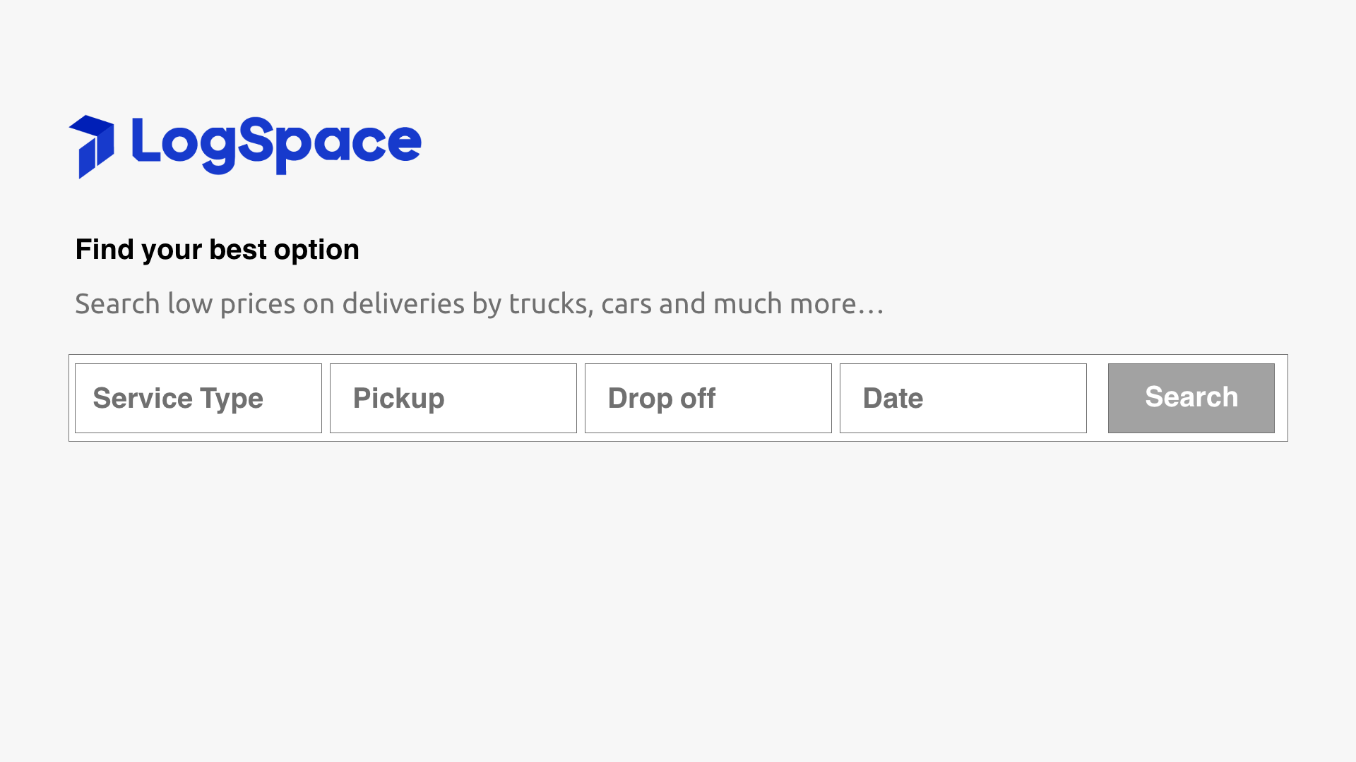
Figure 6 Prototype for main screen to request a service

- Search Screen
  - Search for available vendors/providers based on locations & service
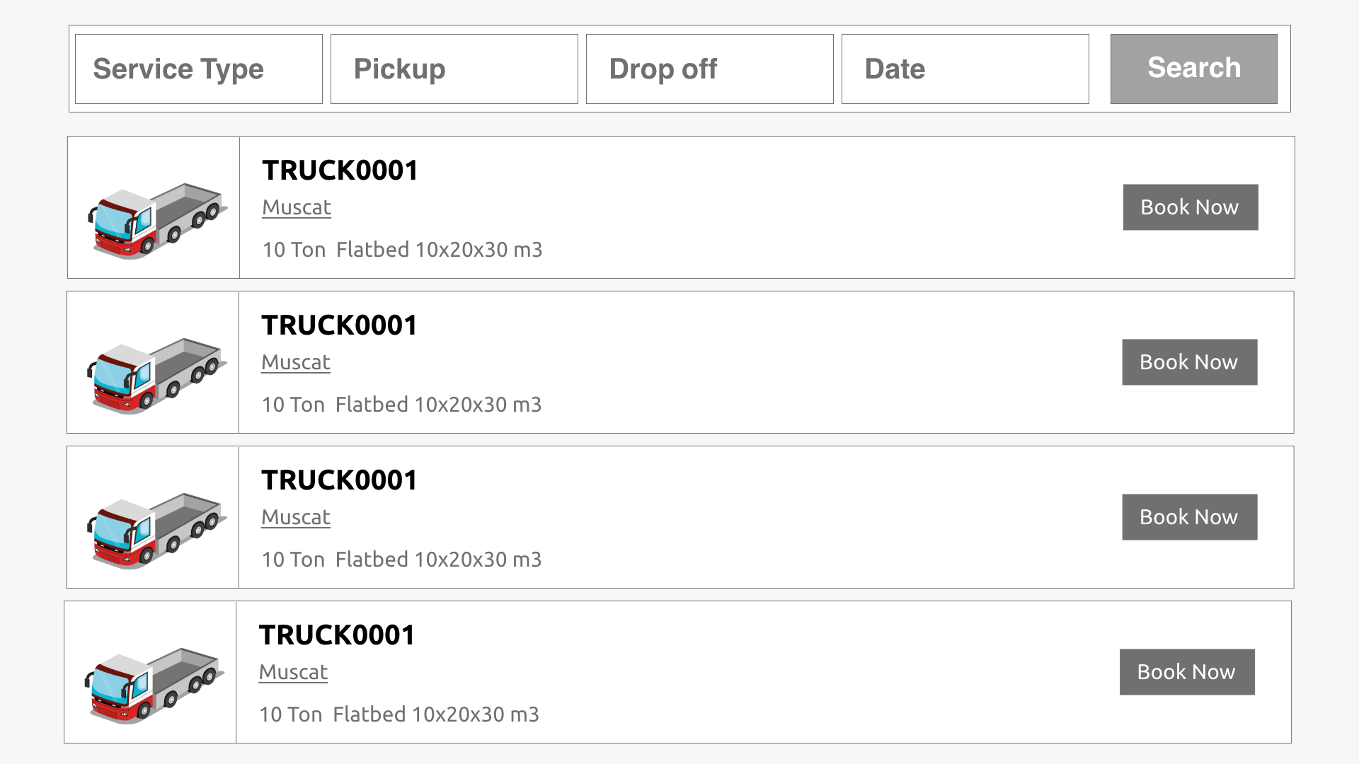
Figure 7 Prototype for search screen on small screen (mobile)
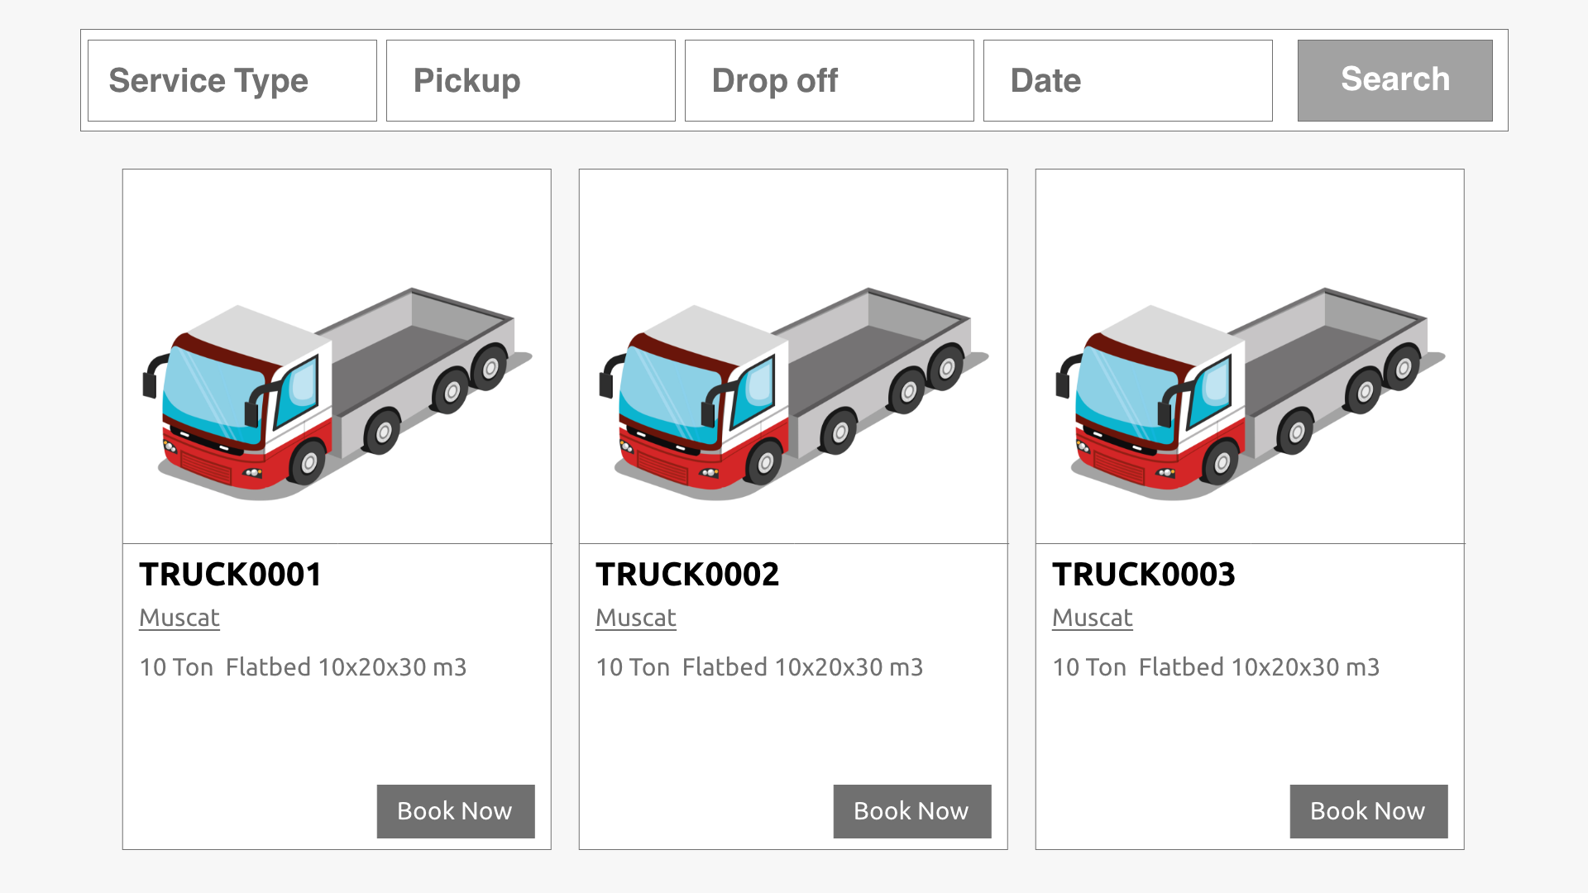
Figure 8 Prototype for search screen on bigger screen (desktop)

- Vendor Selection Screen: Select preferred vendor
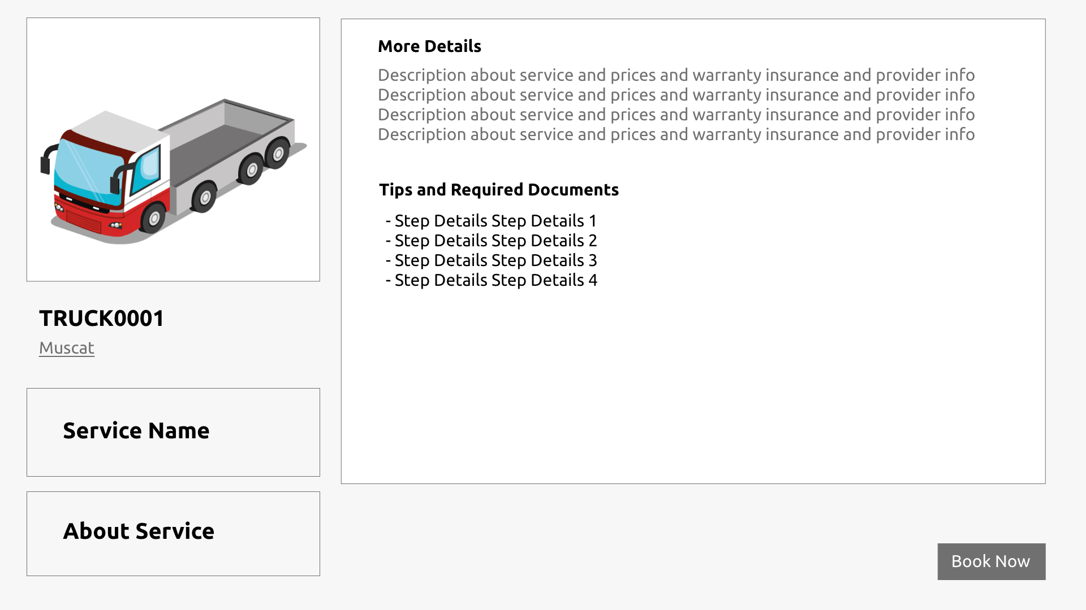
Figure 9 Provider (vendor) details before start booking
- Add-Ons Screen
  - Storage (per day), Custom add-ons or other extra services
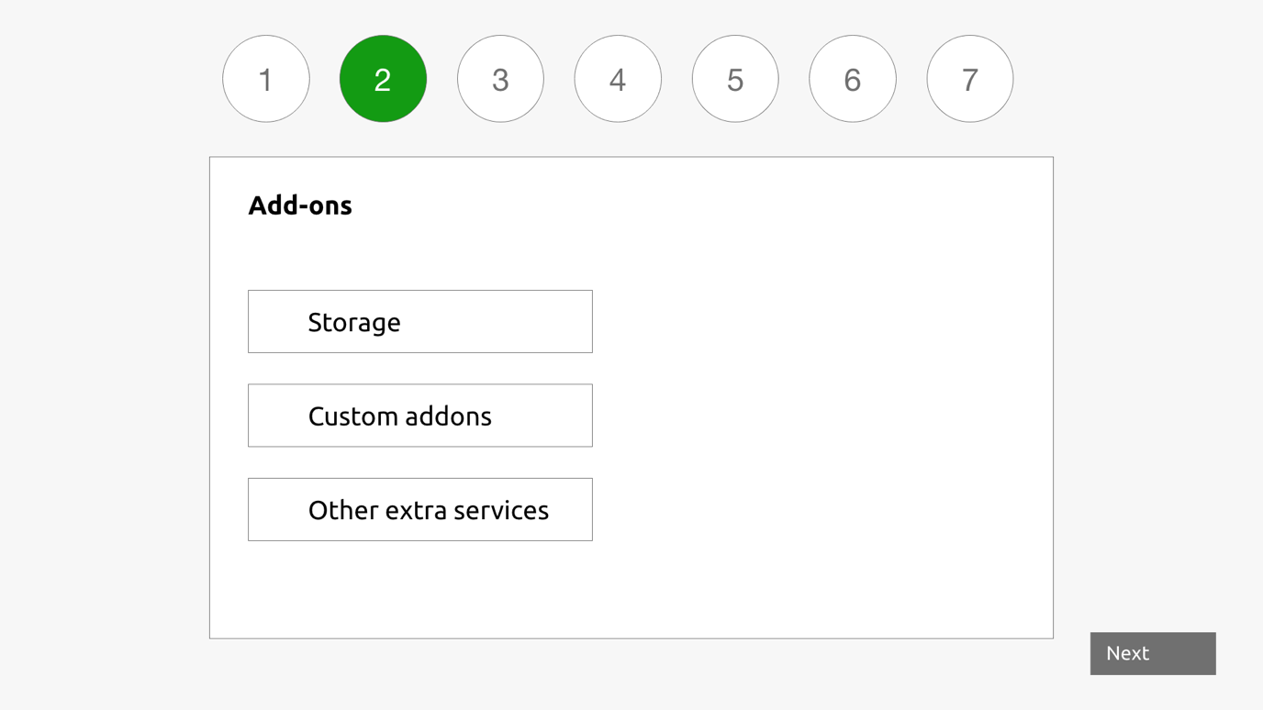Figure 10 Prototype for adding addons

- Order Details Screen
  - Add goods notes
  - Provide pickup and drop-off contact info (name, phone)
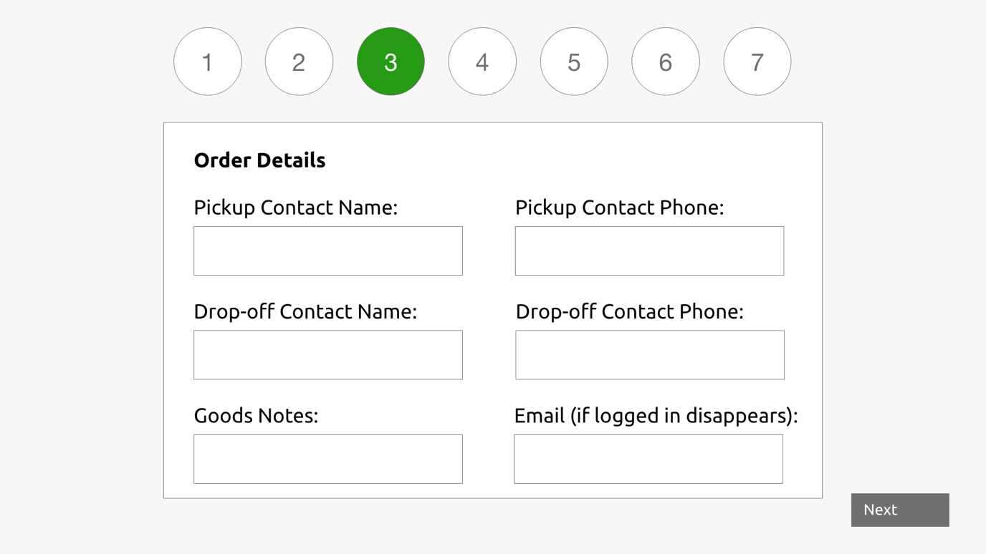
Figure 11 Prototype for additional data in the order

- Checkout & Payment Screens
  - Review order summary
  - Complete payment via payment gateway
  - Done Screen: order confirmation & email notification
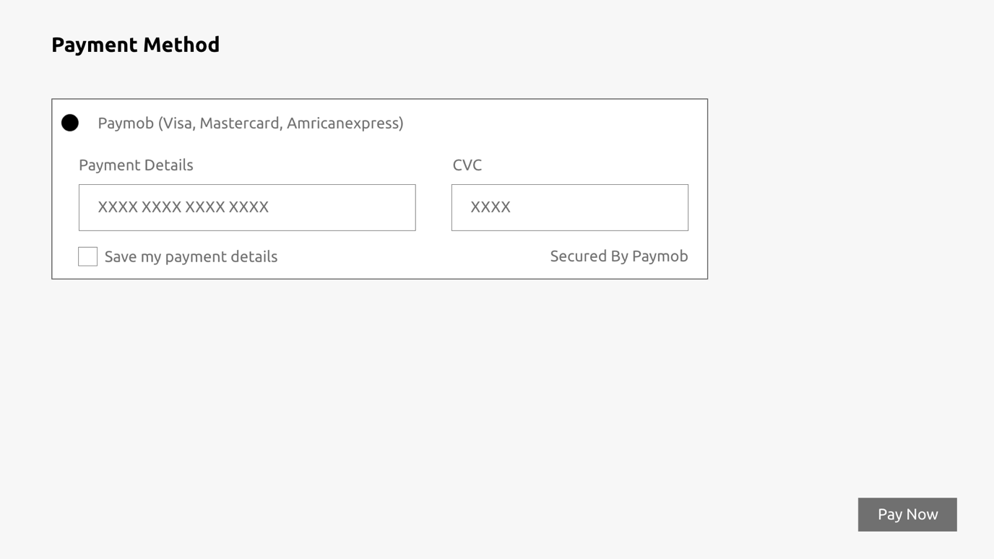Figure 12 Prototype for payment screen

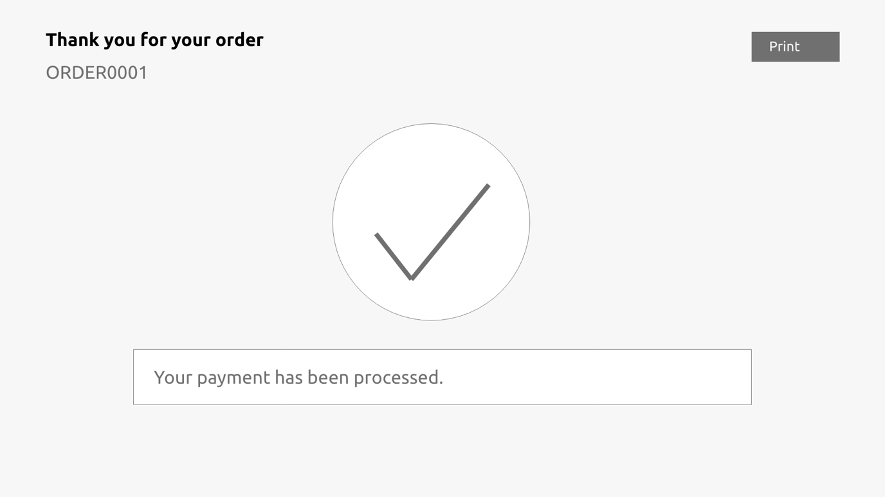
Figure 13 Prototype for booking confirmation

- Customer profile

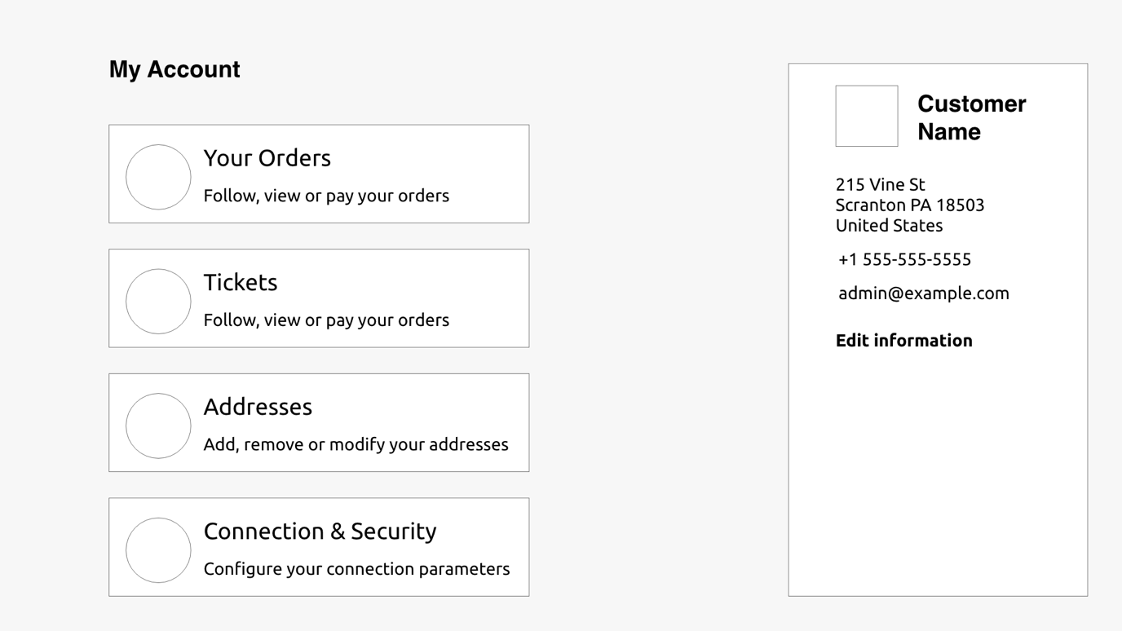
Figure 14 Customer profile sections
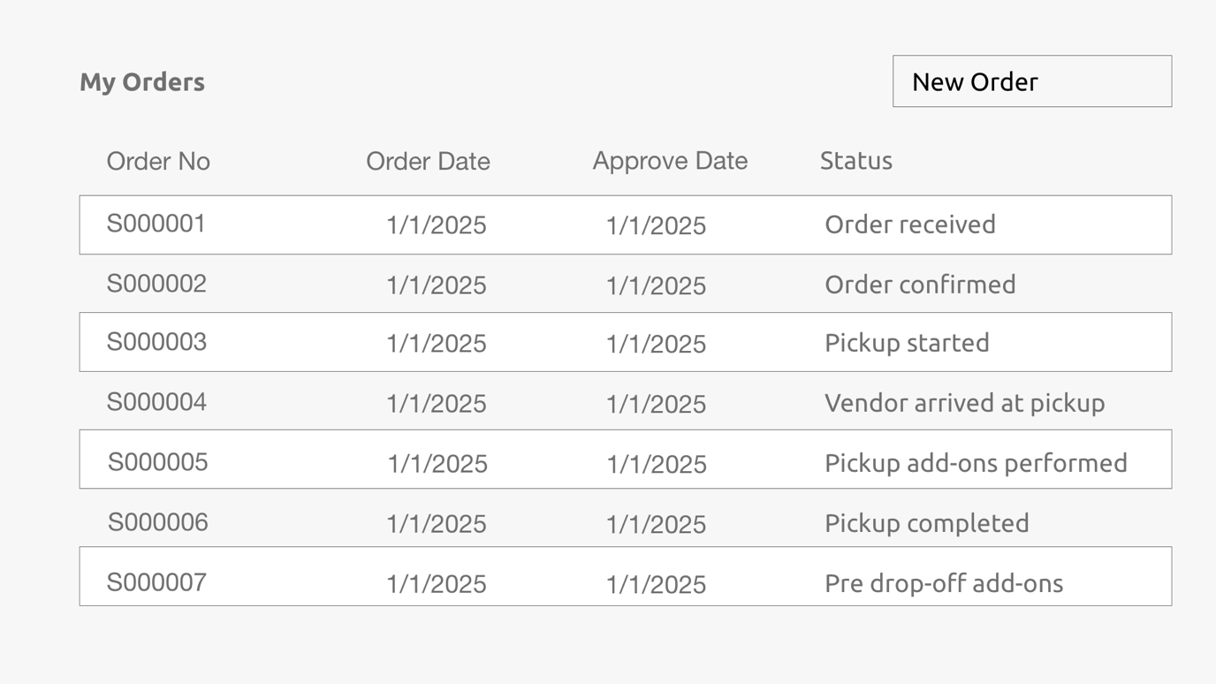
Figure 15 Prototype for all customer orders (Orders history)

Order Tracking & Fulfillment
- Follow-Up / Order Tracking Screen (Customer View)
- Order received → Pickup started → Vendor arrived at pickup location → Pickup add-ons performed → Pickup completed → Pre-drop-off add-ons → Arrived at destination → Drop-off completed → Grace period → Order completed
- Pickup verification code (to be shared from customer to provider for pickup)
- Drop-off code (after pickup, verified at destination)

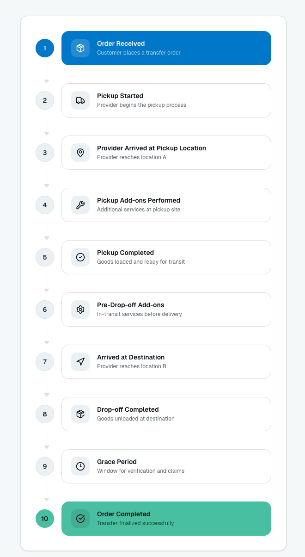
Figure 16 Order workflow diagram and status

Post-Delivery Actions
- Rating Screen (optional)
  - Customer submits star rating (1–5)
  - Optional comment section
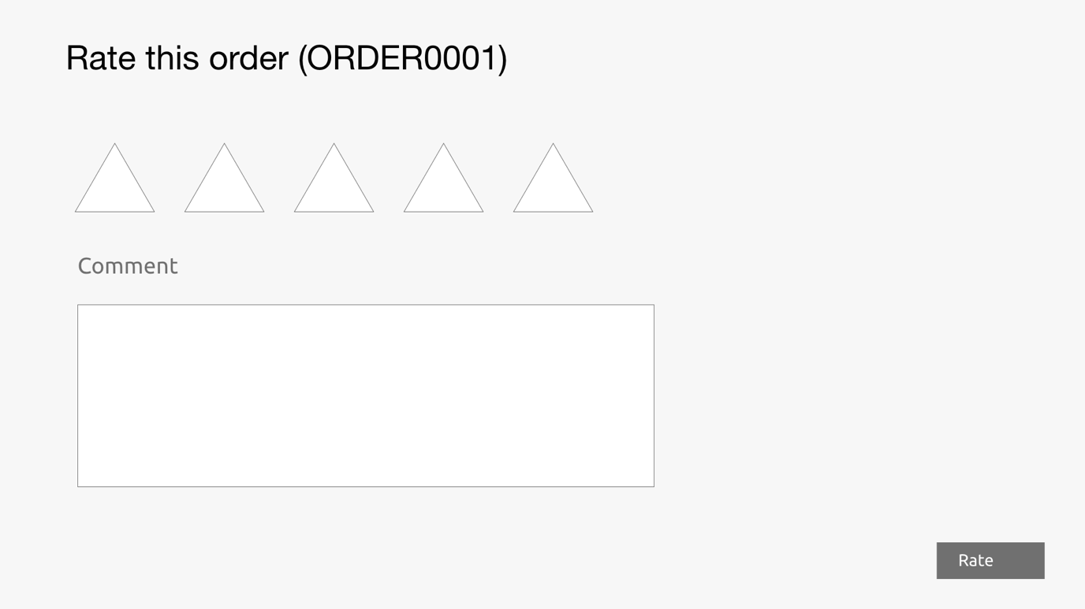
Figure 17 Prototype for rating screen

- Refund Screen
  - According to order stage customer can request for refund
- Ticket Screen
  - Customers can create/view tickets any time after order confirmation
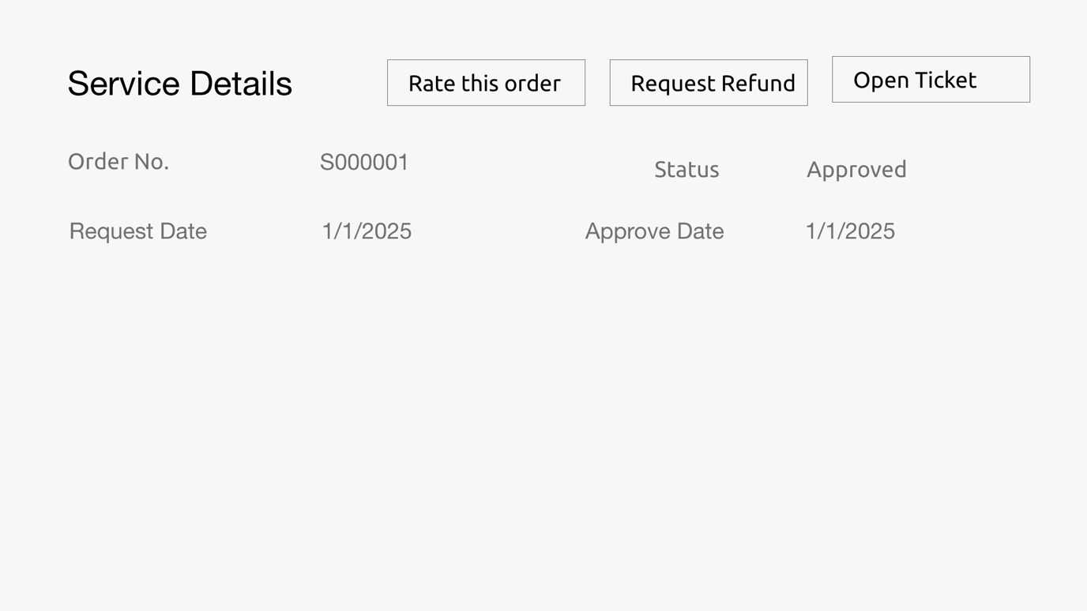
Figure 18 Prototype for rating, request refund and opining ticket options

Provider (Vendor) Workflow
- Vendor registration: basic company information
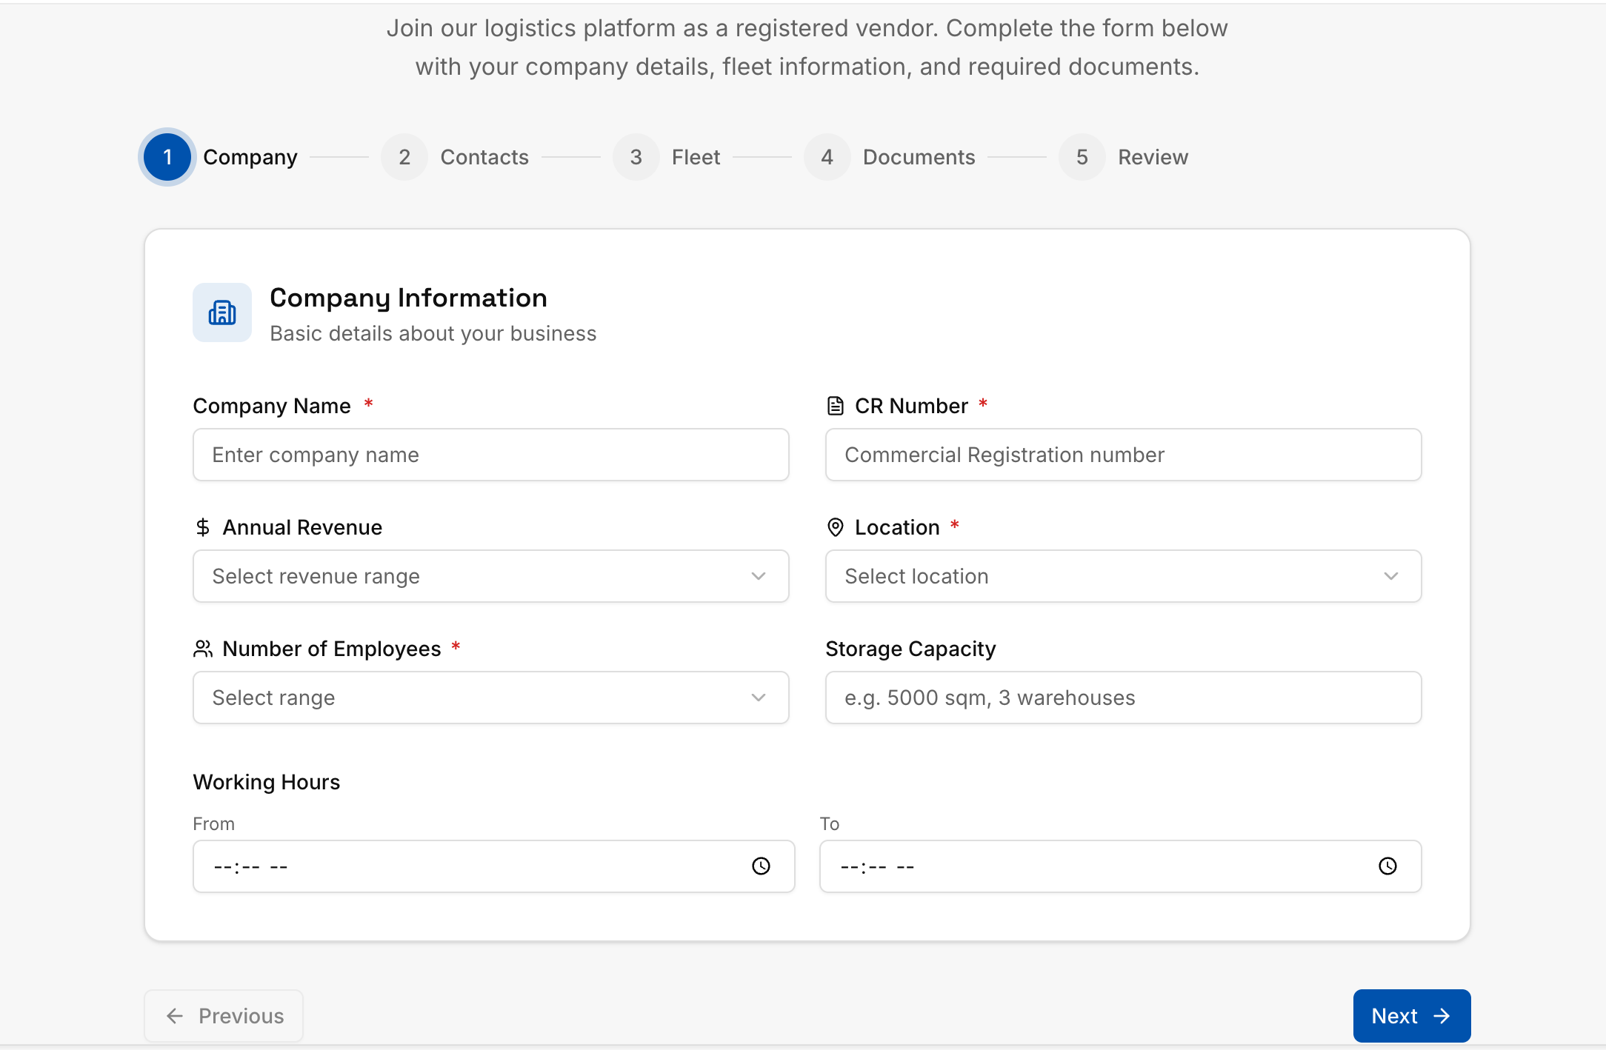
Figure 19 Prototype for vendor registration - basic company info

- Vendor to add contacts and number of users for the platform
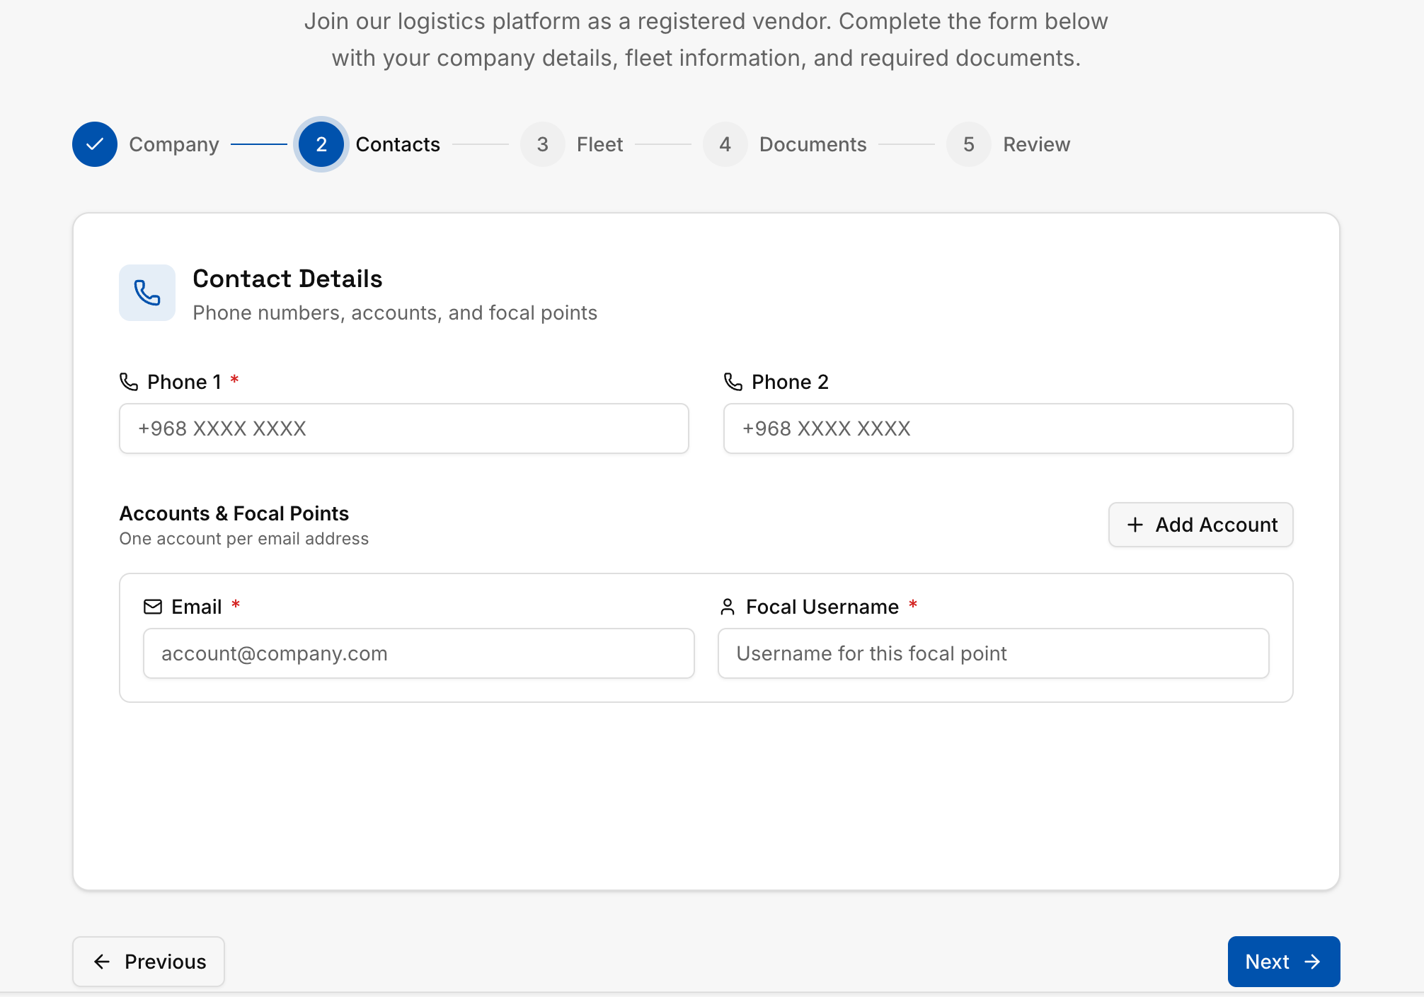
Figure 20 Prototype for vendor registration - contact details

- Vendor to specify the fleets he has
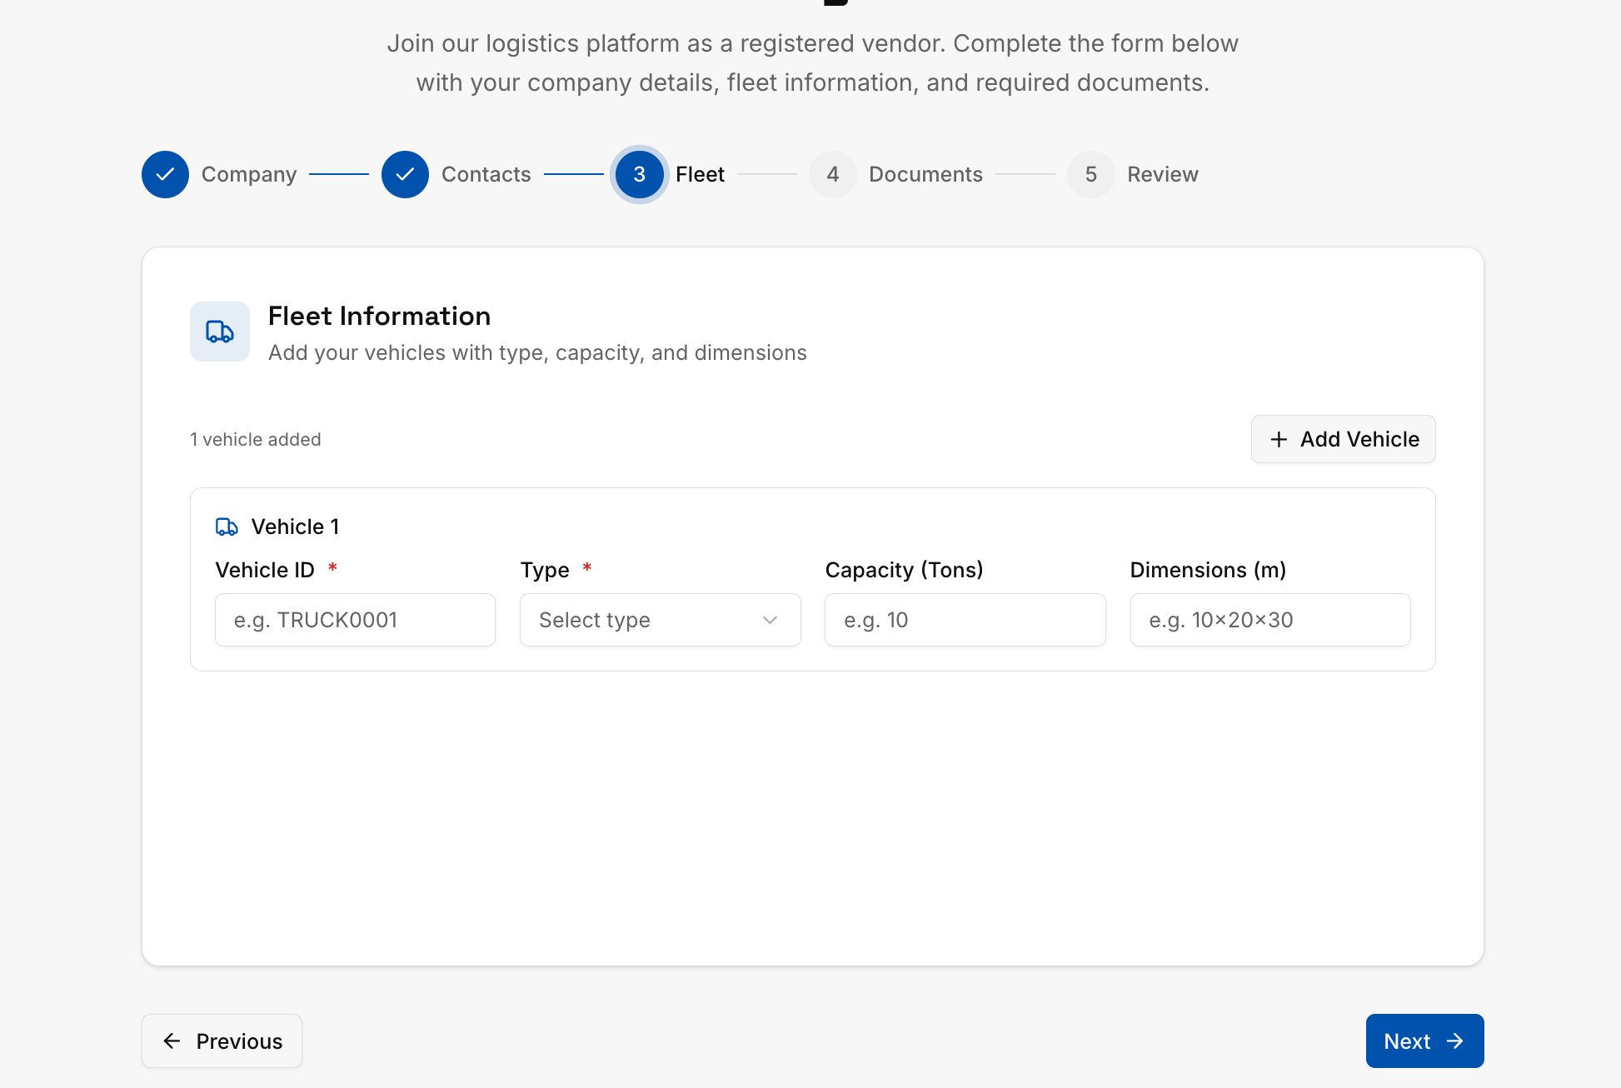
Figure 21 Prototype for vendor registration - vehicles selection

- Vendor to upload company documents
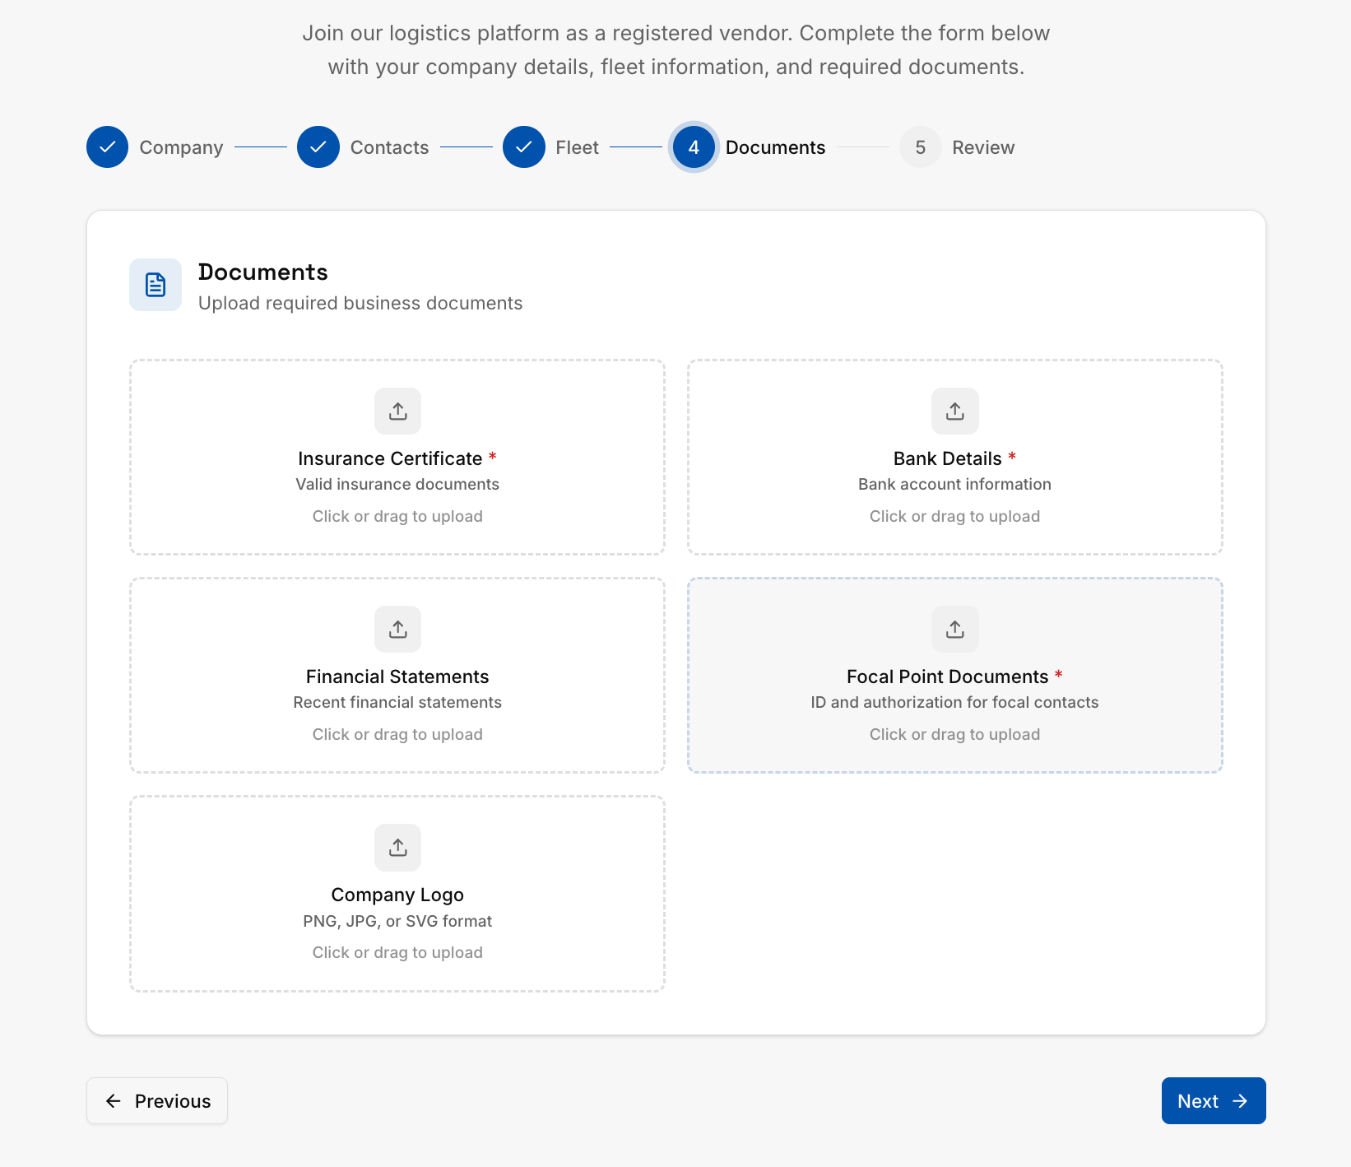
Figure 22 Prototype for vendor registration - documents upload section

- Vendor to review the order before submitting to the management
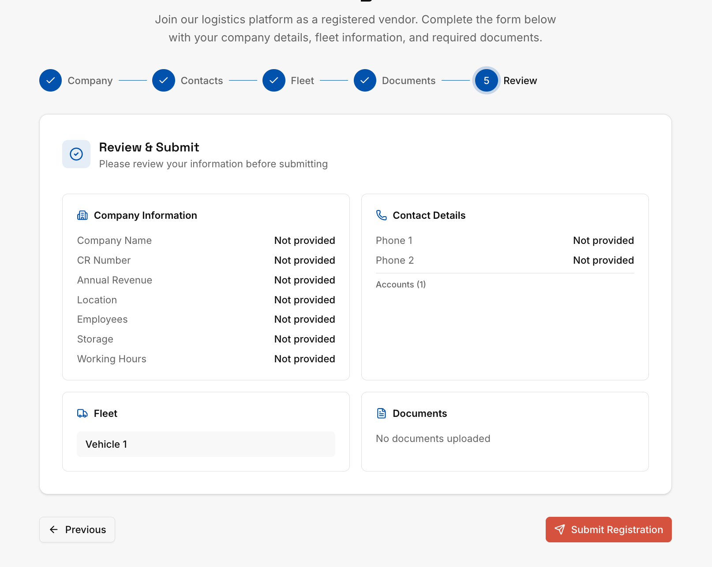
Figure 23 Prototype for vendor registration request summary before submitting

- Vendor to get a confirmation by for order successfully submitted
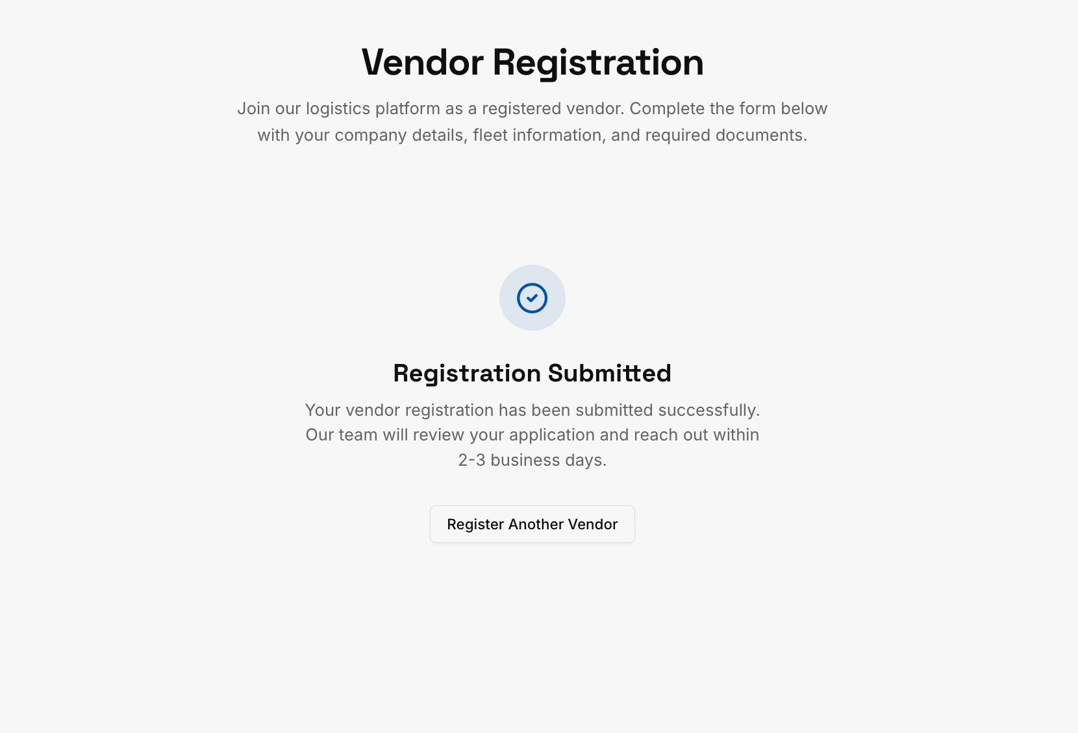
Figure 24 Prototype for vendor request post submit

- Provider acceptance: Admin will review the provider request and then accept or reject, after acceptance the user will be create automatically to the provider, but the admin can still create additional users
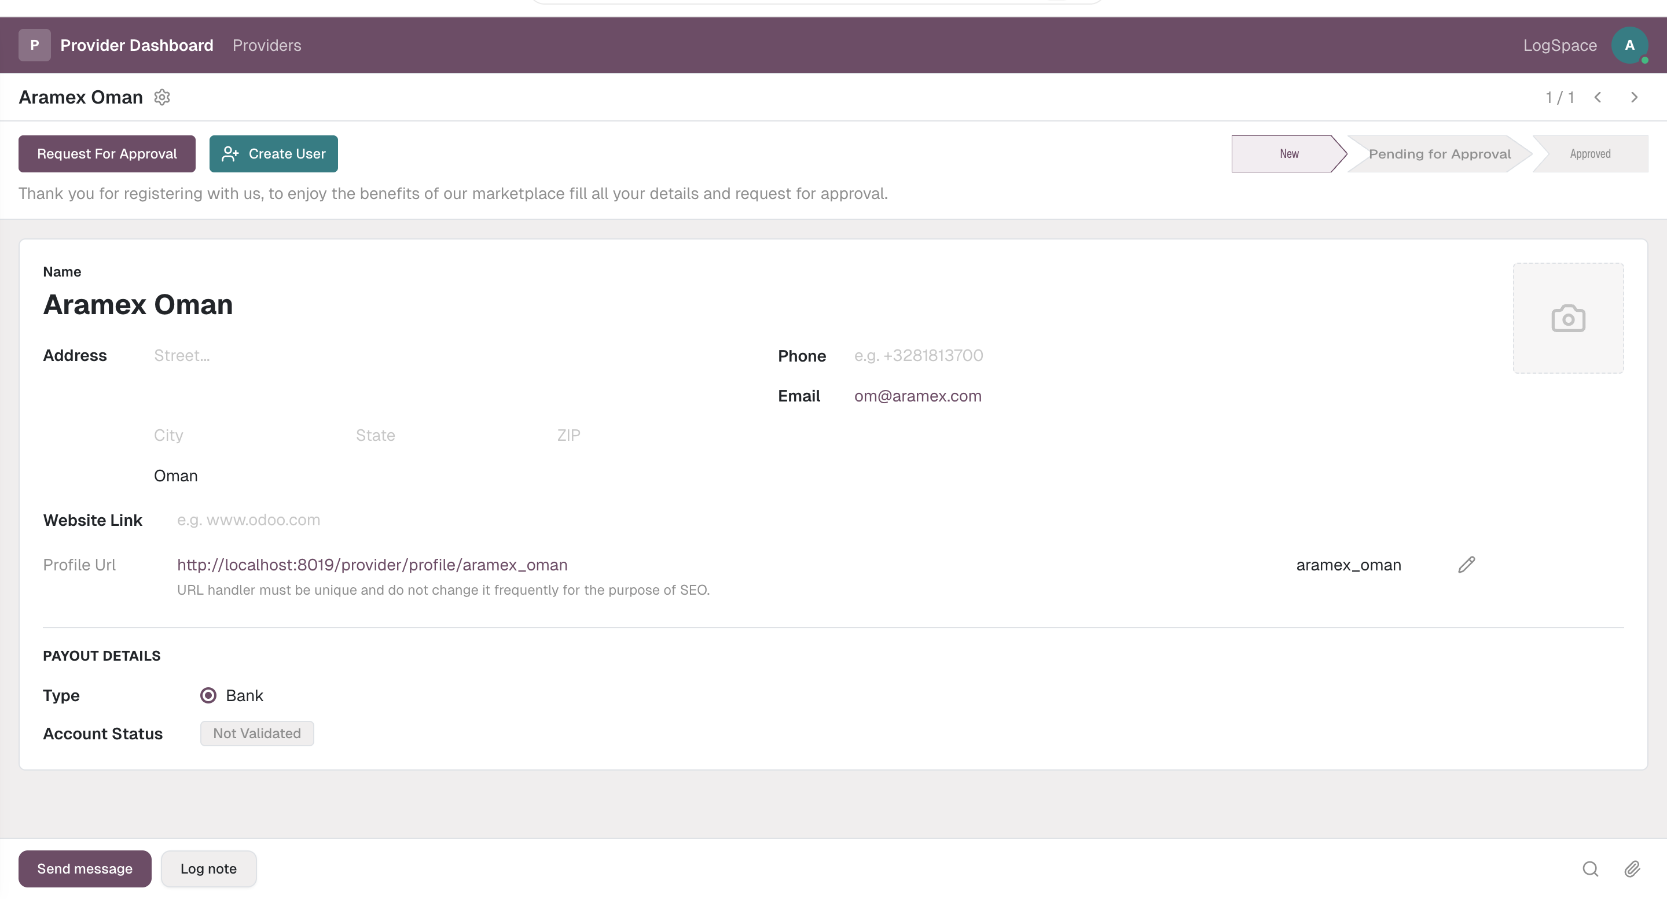
Figure 25 Vendor (Provider) request received in the back office

- The provider can add his services and then update the base price for each service he added per km.
- After adding the services provided can update the prices for each zone
- The provider can also activate zones by selecting the operation zone and then in how much KM he can work and then zones within 100km activated automatically.
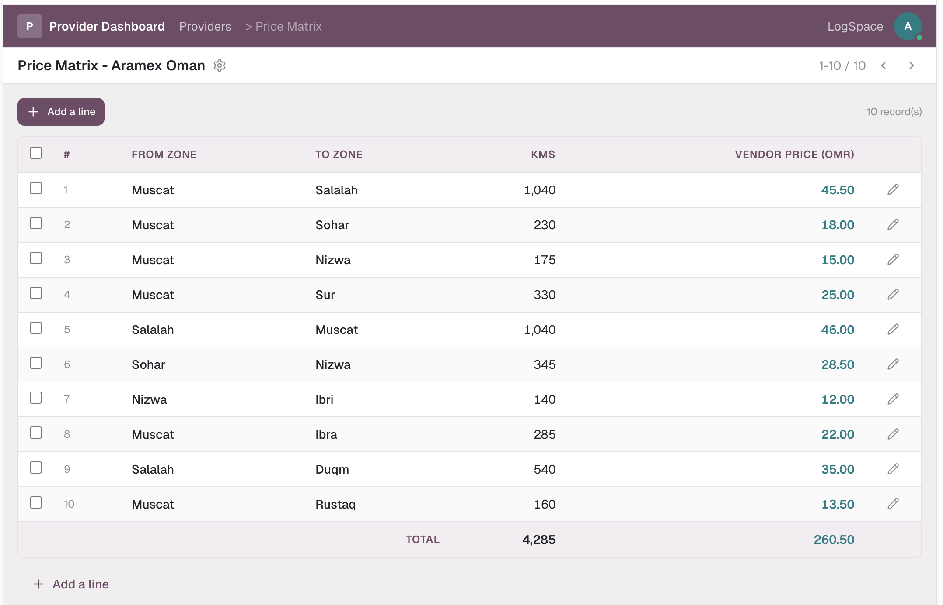
Figure 26 Price matrix to be updatable by the vendor (provider)

- Provider can only mark service as Available / Not Available
- Provider cannot delete service
- The order will be assigned to the provider automatically after the provider selected by the customer
- The vendor will start update order status at each step (Pickup started → Arrived →Pickup (by code confirmation) →Drop off (by code verification) →Completed)
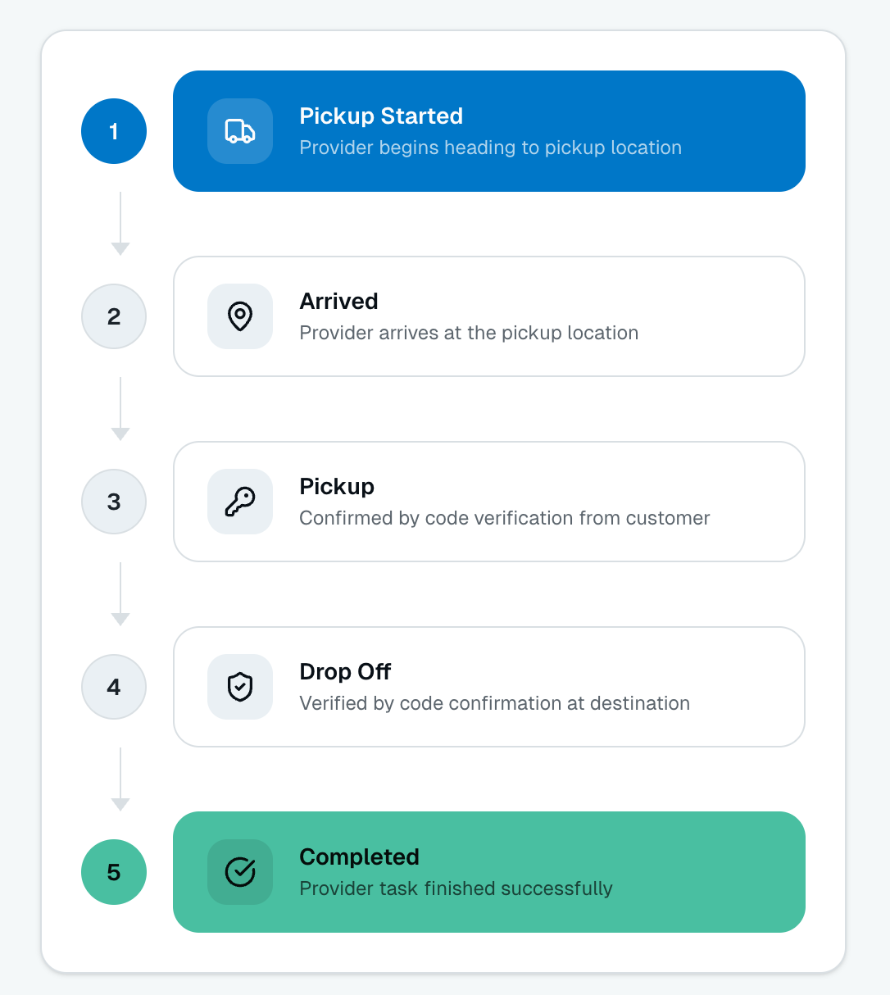
Figure 27 Workflow diagram for the main vendor execution steps
- Execute add-ons:
- Based on the available add-ons selected in the service, vendor will execute them, before picking up add-ons or after drop-off add-ons.

Management workflow
Management will use Odoo back office as the provider but with administration access right to the system
- Define the services:
Add service types with name, picture,
- Addons types:
Adding addons name, unit of measure, execution time (before pickup or after drop-off)
- Price matrix KMs for zones:
Add and update zones and KMs between zones
- Update time frames (morning, afternoon, evening)
- Provider (vendor) request approval:
Review and approve vendor request to join LogSpace
- Create users for providers to use the platform
- Provider payout:
Pay commissions to the vendors.
- Refund processing:
Process the refund amount to the customer posted on a valid refund request.
- Ticket resolving
Resolve a ticket and get back with the response to the customer
- View reports and dashboards:
View the system statistics and dashboards,
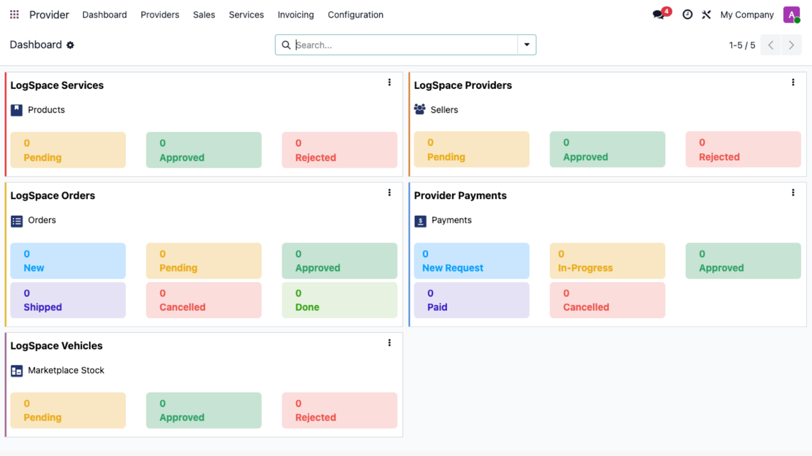
Figure 28 Prototype for the admin dashboard and statistics

System workflow
- User will start search an order first
- Then the system will automatically create the draft sale order for the customer
- Then after the customer paid the order successfully, the system will create an invoice for the customer and a purchase order to the vendor
- After the vendor complete the order successfully the system will create a bill for the vendor
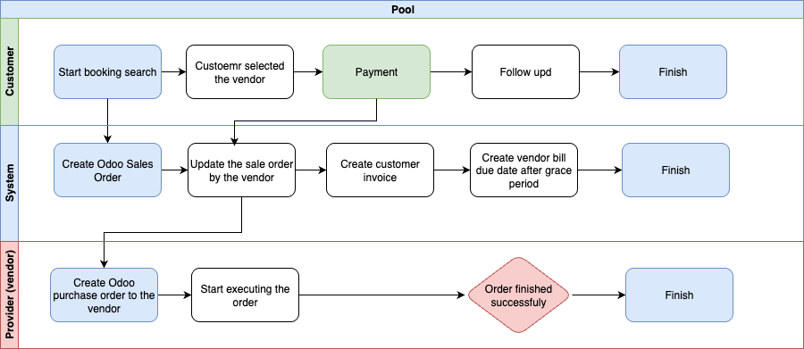
Figure 29 Order invoicing workflow diagram between customer and vendor through the system

Critical Acceptance Criteria and Success Factors
Module | Accounting
LogSpace functionalities | Customer order request
LogSpace functionalities | Customer registration
LogSpace functionalities | Price matrix
LogSpace functionalities | Pickup and drop off process
LogSpace functionalities | Auto sales order, purchase order and vendor bill
LogSpace functionalities | Reporting

Appendix A – Additional clarification and workflows

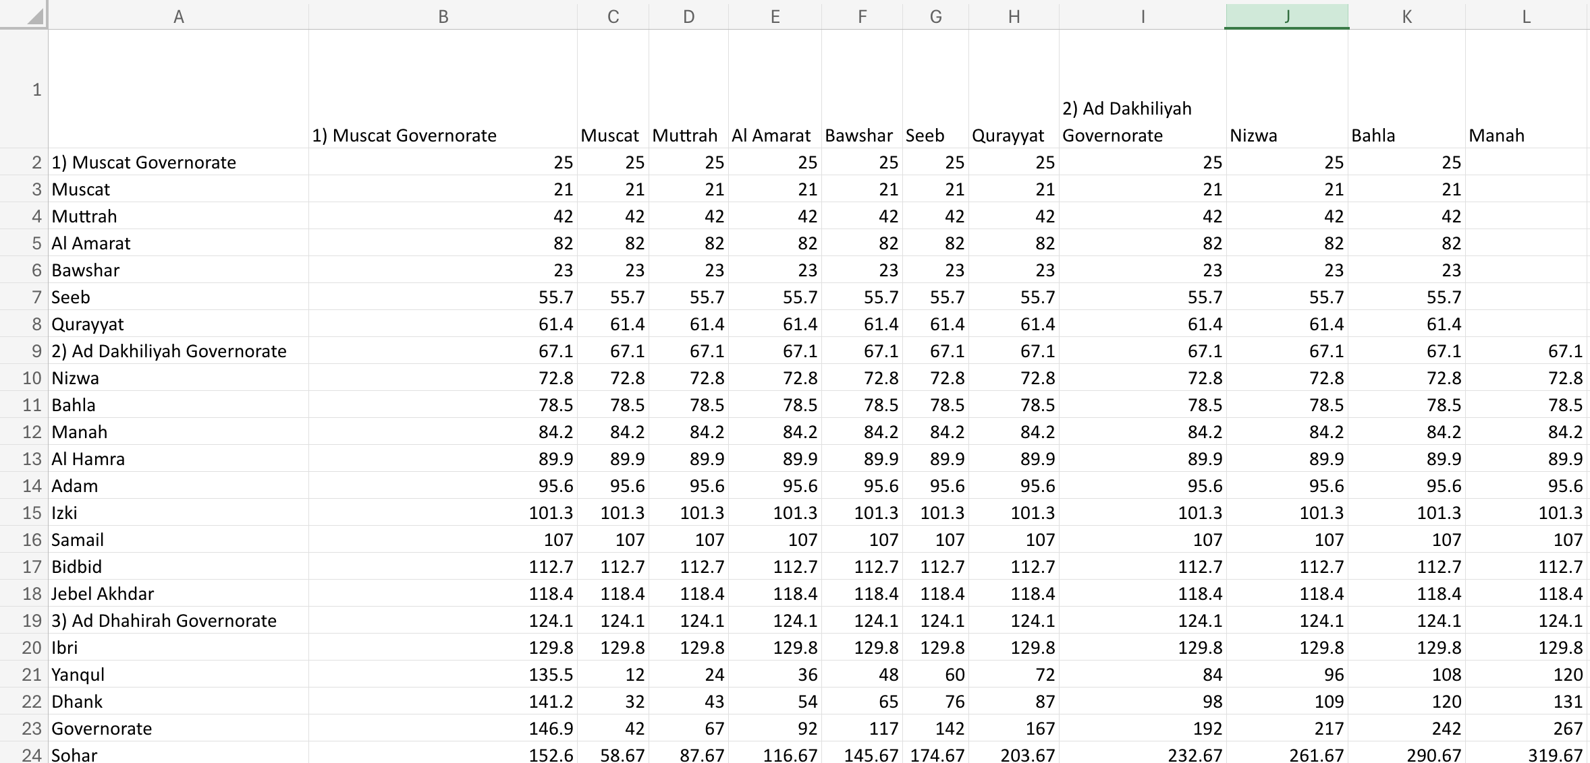
Figure 36 Sample of the price matrix that will be prepared and uploaded to the system Oman states and to be updated later by the admins

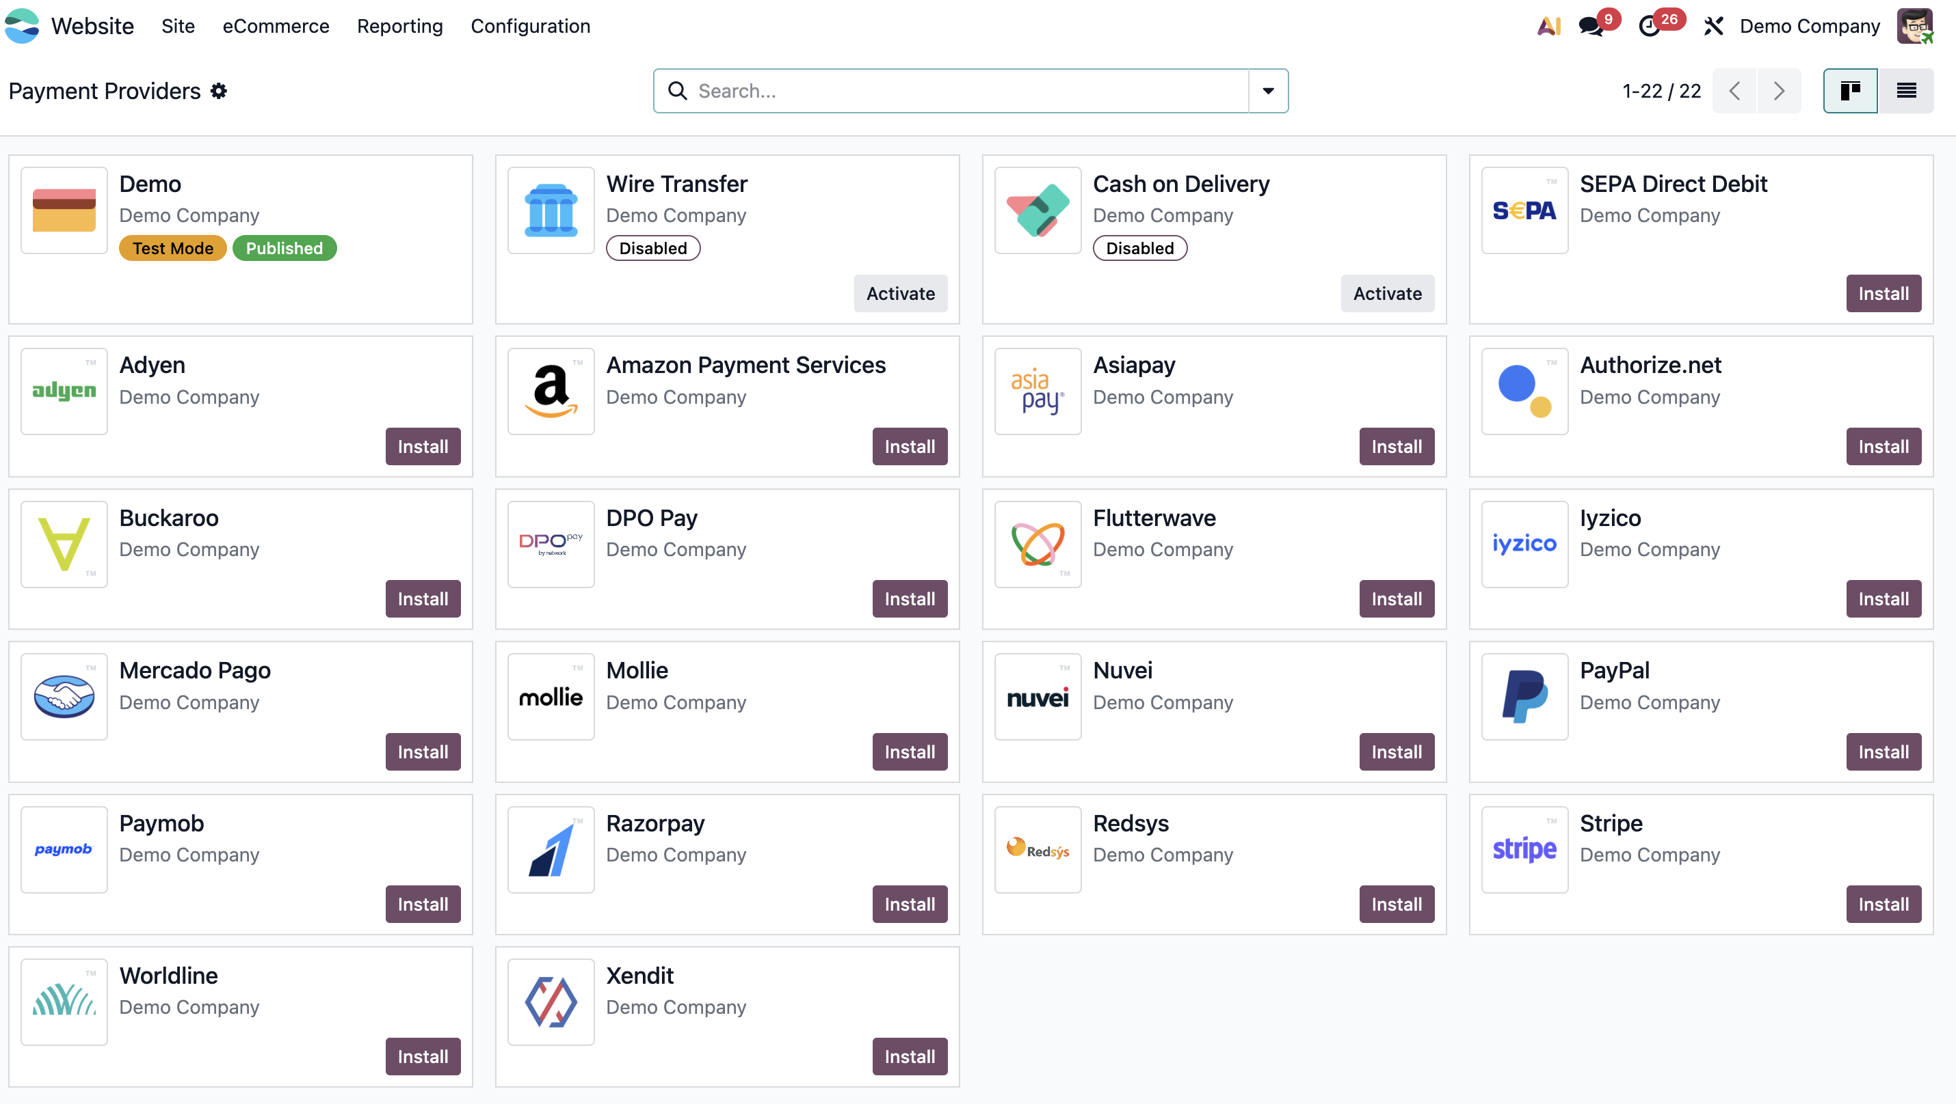
Figure 37 Available standard payment providers

Appendix B – Important notes

Users
- Admins and Vendors (Providers) will be considered back-office users and will require user licenses.
- Guests and Customers will be considered portal users and will not require licenses under Odoo 19.

Change request (CR)
- Any changes to the workflow defined in the SRS, addition of new processes, new business applications, or changes in the standard Odoo, will be considered as a change request.
- Adding new fields, adjusting website colors, or rearranging front-end sections will not be considered a change request before wireframe approval (subject to technical feasibility). After wireframe approval, such changes will be limited to a maximum of 15 development hours.

Server and Domain
- The system can be deployed either on Odoo.sh or on a prepared cloud-based VPS server (minimum 8 GB RAM), and the RAM needs to be increased based on the number of concurrent users.
- The domain is configurable by default with SSH access on Odoo.sh, while on a VPS an SSL certificate must be configured separately.

Data
- A basic chart of accounts, general distance data between Oman states (in KM), and basic truck icons from free sources will be provided to ensure system readiness.
- The system administrator can later update existing data or add additional data as needed.
- All master data except basic chart of accounts, and general distance data between Oman states must be provided by LogSpace team.

Diagram and workflows
The diagrams and workflows mentioned in the section 5.5 are only explaining the process flow, the real design will be designed according to the Odoo standard design concept for front end and for back office.

